

**Application of the Protein connectivity network (PCN) for Data Mining of B cell receptor protein sequences.**

**Project Number: 22-1-R-17**

**Capstone Project Phase B**

**Developer manual**

**Khalil Daibes – 315688960 Email: khalildaibes1@gmail.com**

**Lotem Eliyahu– 204110506 Email: eliyahulotem@gmail.com**

**Supervisor: Dr. Zakharia Frenkel**

**Introduction:**

**Getting started:**

**System requirements**

**• Python3 installed**

**• Internet connection**

**• install python pip**

**Third party components**

**• Pajek**

**Cloning the project:**

**1.First clone the repo frpm this github repo.**

**2.Open the editor programming software that you prefer ( we recommend pycharm ).**

**3.Open the terminal and write this command**

**pip install -r requirements.txt**

**4.Start altering the program code**

**Upgrading libraries:**

**First you have to upgrade the library then indicate the version of the library in the requirements file.**

**recommended use** pip3 freeze > requirements.txt # Python3

pip freeze > requirements.txt # Python2

**Herichia of the program:**

**the herichia of the program is a simple gui db connection and a logic(main) packages**

**each one is responable for its meanted naming pourpse.**

**The gui file is for showing the user interface.**

**The main file is for creating the networks.**

**The db copnnection file ios for fetching data from th remote database.**

**The application starts from the main_screen function in GUI.**

**Package diagram:**

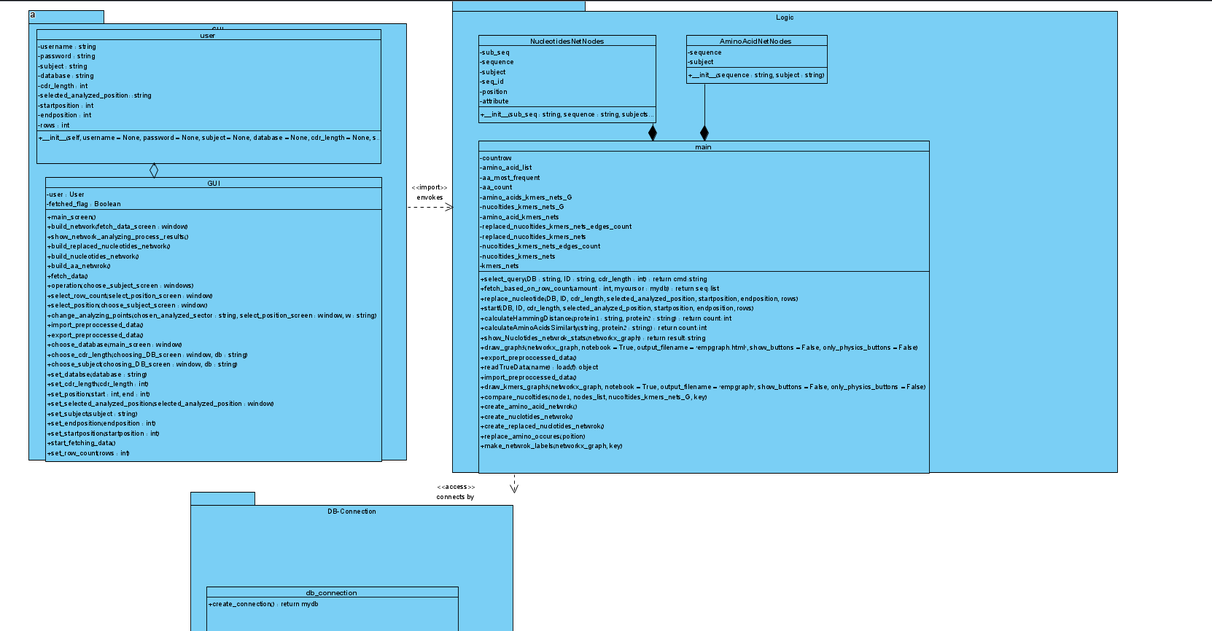

**Deployment diagram:**

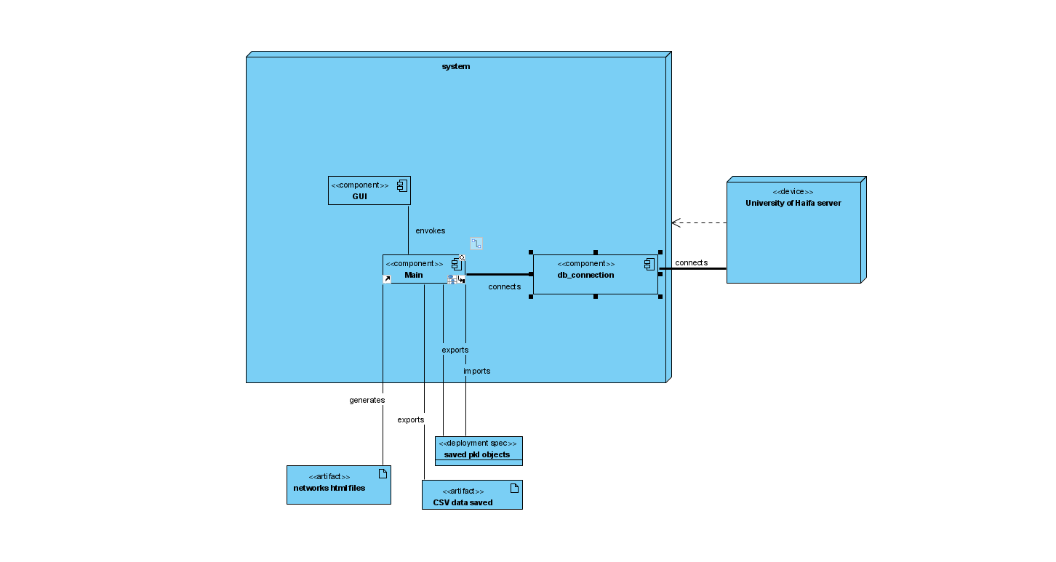

**DataBase:**

**The database is splitted into a couple of databases.**

**We worked with covid vaccine new and covid published**

**The tables contain the data.**

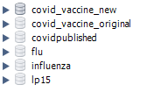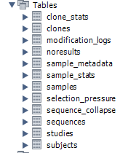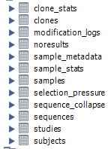

**Tables construction:**

For each used tables in our program find attached table construction photo description.

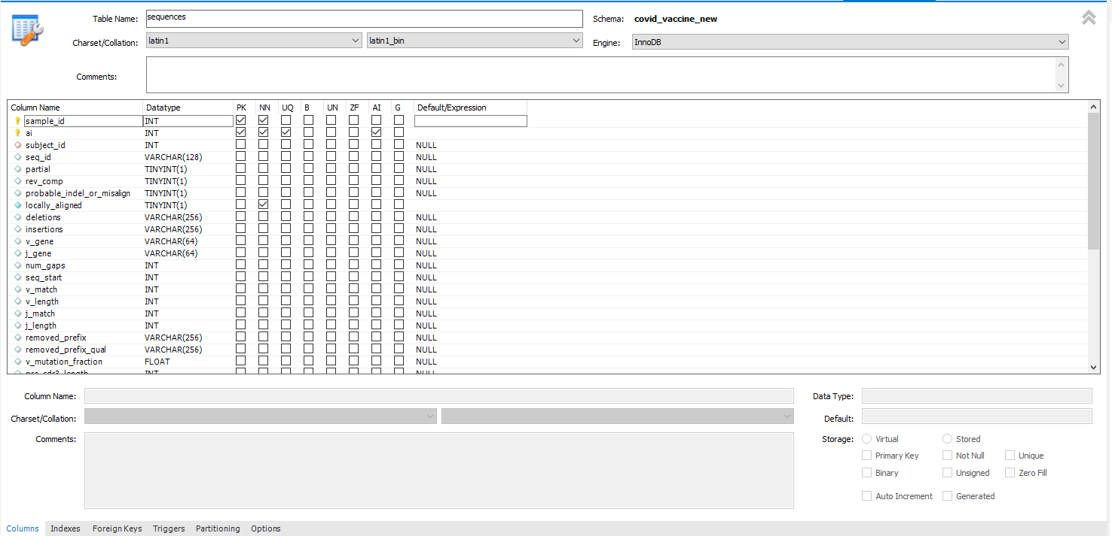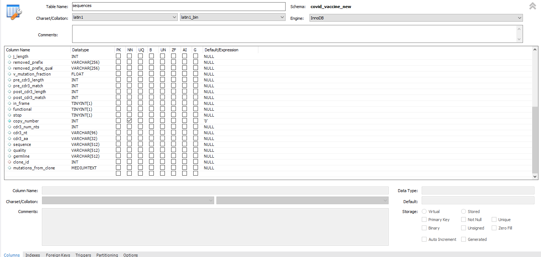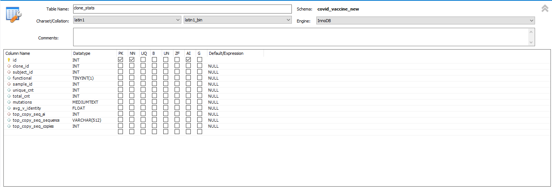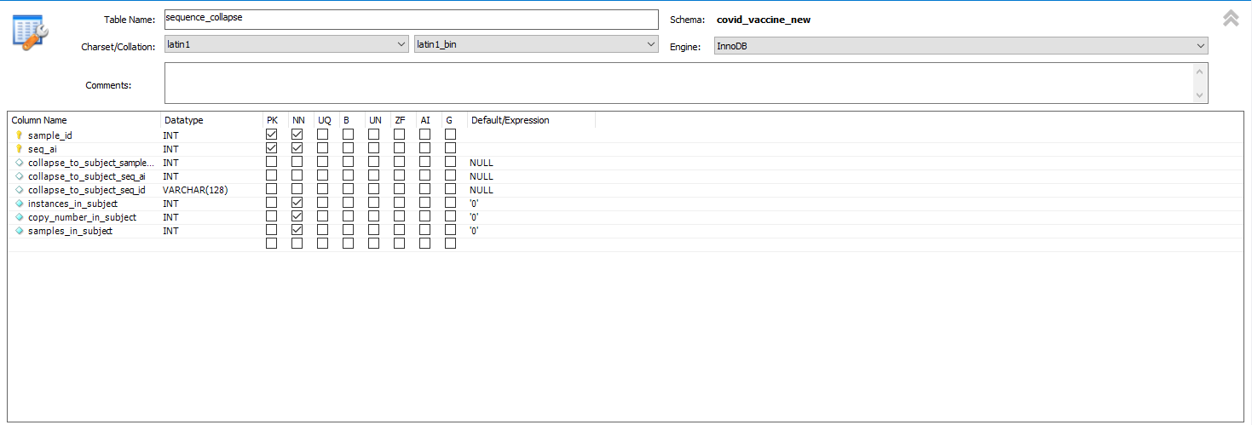

Note:

For both of the tables we have the same construction details.

For analyzing the result networks using Pajek:

Download Pajek from: <http://mrvar.fdv.uni-lj.si/pajek/>